Chapter
Job Design and Work Measurement

Discussion Questions
1. One would expect that elements of Maslow’s needs hierarchy, Herzberg’s Dual Factor theory, and Hackman and Oldham’s core job characteristics would be contained in the answer.
2. Jobs have been considered “bad” because they are physically dangerous, “dirty,” or “noisy”; psychologically repulsive, too mo-notonous; present too great a physical or intellectual challenge; or offend an individual’s preferences with regard to general lifestyle or employment. Students should be encouraged not to identify a particular “right” job, but to try to identify precisely what issues relevant to the job appeal to or offend him or her. Note the core job characteristics of Hackman and Oldham: skill variety, job identity in job significance, autonomy, feedback.
3. Again, there is no set answer to this question. The important considerations are:
- The changes suggested should address the reasons that the original job was considered “bad”—not merely make the job different.
- The changes must be realistic—resources must exist or must be able to be developed that would allow implementation of the suggested job changes.
- The student should be encouraged to consider the difference between “production” and “productivity.”
4. Jobs that can push the man-machine interface to the limit of man’s capacity usually require a high rate of information processing, a high rate and accuracy of physical response, or both. Examples would be found in terms of pilots of high-performance jet or rocket-powered aircraft, crane operators, and a safety monitor for working at a nuclear power station.
5. The student should be encouraged to include Hackman and Oldham’s five core job characteristics of skill variety, job identity, job significance, autonomy, and feedback.
6. Job enrichment relates primarily to increasing the cognitive
or intellectual requirements for the job, often by increasing
authority and responsibility.
Job enlargement relates primarily to an increase in the number of tasks to be performed.
Job rotation implies a formal arrangement for job switching among a particular group of workers within a specific set of jobs. Usually the workers are cross-trained on all or most jobs within the set.
Job specialization implies the opposite of job enrichment or job enlargement, where the job becomes narrow and the range of responsibility and authority restricted.
Employee empowerment is the practice of enriching jobs so that employees accept responsibility for a variety of decisions normally associated with staff specialists.
Teams often satisfy empowerment, core job characteristics, and higher level needs.
7. Ergonomics is the study of human factors, the study of work.
Ergonomics can make work safer, less damaging, by redesign to tools, workspaces, and worker motions.
8. Techniques for methods analysis include: flow diagrams, process charts, activity charts, and operations charts.
9. Labor standards are set in four ways: historical experience, time studies, predetermined time standards, and work sampling.
10. Labor standards are used to:
1. Determine labor content of items produced
2. Determine staffing needs of organizations
3. Determine cost and time estimates prior to production
4. Determine crew size and work balance
5. Determine production expected
6. Determine the basis of wage-incentive plans
7. Determine efficiency of employees and supervision
11. Classify as follows:
a) The operator stops to talk to you: do not include (delay)
b) The operator lights up a cigarette: do not include (personal)
c) Operator opens lunch pail: do not include (personal)
12. Waiting time: waiting time is included in an allowance as delay.
13. Material movement or replenishment: include in the standard unless a separate materials handling group exists.
14. Operator drops a part, you pick it up and hand it to him: do not include. Outside help or interference distorts the results of the study.
Active Model Exercise
Active Model 10.1: Work Sampling
1. Scroll over the graph to determine what the sample size should be if p = 30%.
933
2. Based on the graph, what value of p requires the largest sample size?
0.5
3. Use the scrollbar to determine what happens to the sample size as the number of standard deviations, z, increases?
The sample size increases.
4. Use the scrollbar to determine what happens to the sample size as the acceptable error, h, increases?
The sample size decreases.
Ethical Dilemma
McWane Inc. is an interesting company—a repeat polluter, a dangerous workplace, a tough management team, privately held—yet it is a major philanthropic family in Birmingham and is respected for what it has given the city culturally. It also claims to be “cleaning up its act” in response to the terrible publicity it has received over the years. Students should use the Internet to update the 2003–2004 New York Times and The Wall Street Journal articles sourced. This will make for a lively classroom discussion.
(a) A new company nurse at McWane. Should she contact OSHA, quit, force the issue with management? These are usually no-win situations for employees.
(b) A purchase of McWane’s products. Do you insist on ethics in your supply chain? This is an issue facing U.S. clothing makers whose factories are in China, Bangladesh, and Vietnam. Public opinion usually forces companies to insist their suppliers follow the same code of ethics they apply internally.
(c) McWane’s banker. Do you intrude on your good customer’s business ethics or keep your eyes and ears closed, hoping the attorneys and accountants handle the bad press?
(d) A supplier to McWane. Do you tell McWane you will not sell them $10 million in material per month because you don’t approve of their treatment of employees and the environment? Are you responsible to your shareholders to make a profit or set standards for a customer’s ethics?

End-of-Chapter Problems

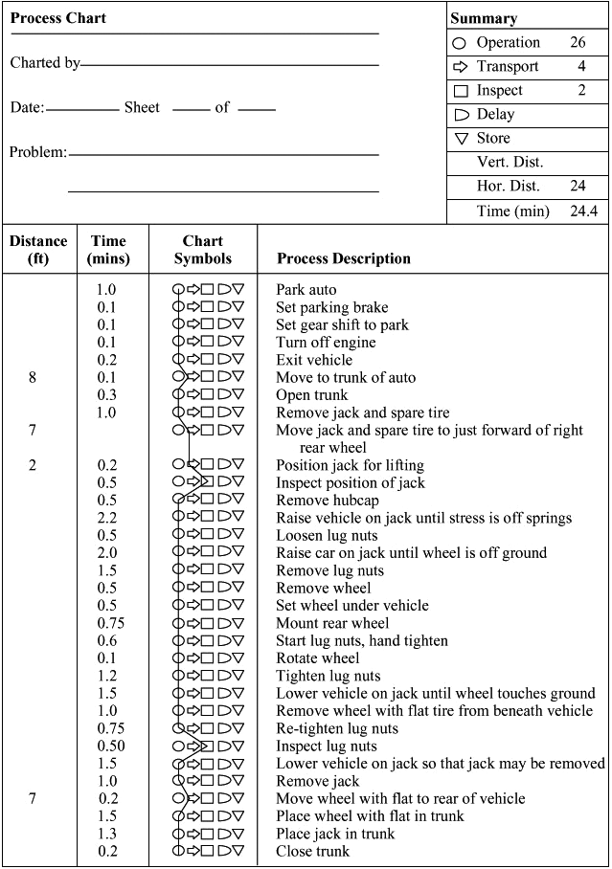
10.1

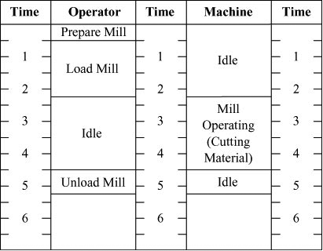

10.2

10.3 This problem is probably best solved by students who have experienced one of these concerts! Of major importance in the so-lution is that everything be coordinated (both performers and sets may have to be changed; performers may have to change costume, etc.) and that all performers be allowed time to recuperate.

10.4

The operations chart presented here as a solution to part (a) is typical of left-hand/right-hand charts, containing numerous small motions. Placing a paper clip on a set of papers is somewhat simpler, but contains many of the same motions. Adding paper to a printer might be more complex, and might require more mechanical dexterity or strength, but it too could be analyzed with a chart analogous to this one.

The operations chart presented here as a solution to part (a) is typical of left-hand/right-hand charts, containing numerous small motions. Placing a paper clip on a set of papers is somewhat simpler, but contains many of the same motions. Adding paper to a printer might be more complex, and might require more mechanical dexterity or strength, but it too could be analyzed with a chart analogous to this one.

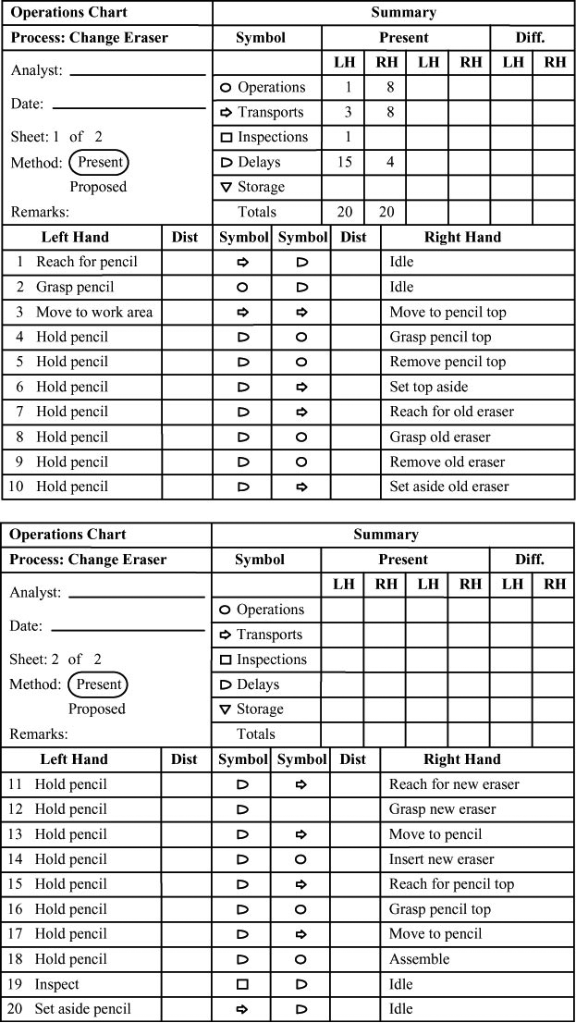

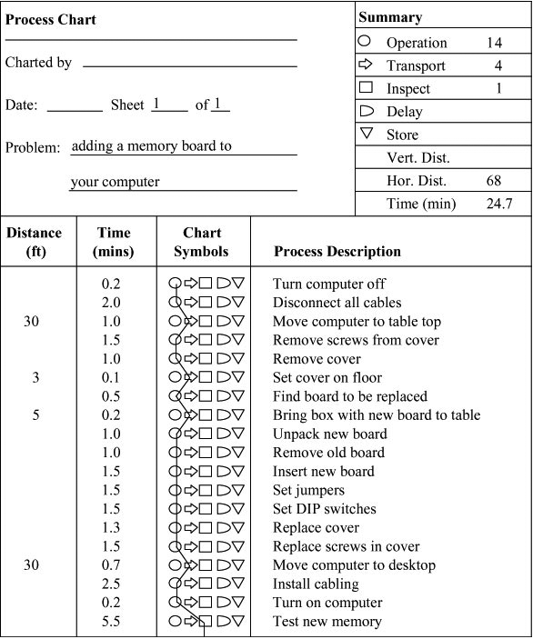

10.6 The important point raised by this question is that actual ratings will depend on both the job and the psychological needs of the individual student. Students should be encouraged to evaluate the degree to which they require each of the psychological components cited by Hackman and Oldham; then to evaluate several jobs.
10.5
The following two examples are offered:

Job Characteristic | Example 1:  Fast-Food  Kitchen Staff |  |  | Example 2:  College  Professor
Skill variety | 3 |  |  | 5 |  |  | Changes that might lead to higher
Job Identity | 4 |  |  | 9 |  |  | score: for the fast-food worker, job
Job Significance | 3 |  |  | 8 |  |  | enlargement would lead to greater job
Autonomy | 4 |  |  | 9 |  |  | variety. For the college professor,
Feedback | 7 |  |  | 6 |  |  | more frequent performance reviews.
Total |  | 20 |  |  | 37

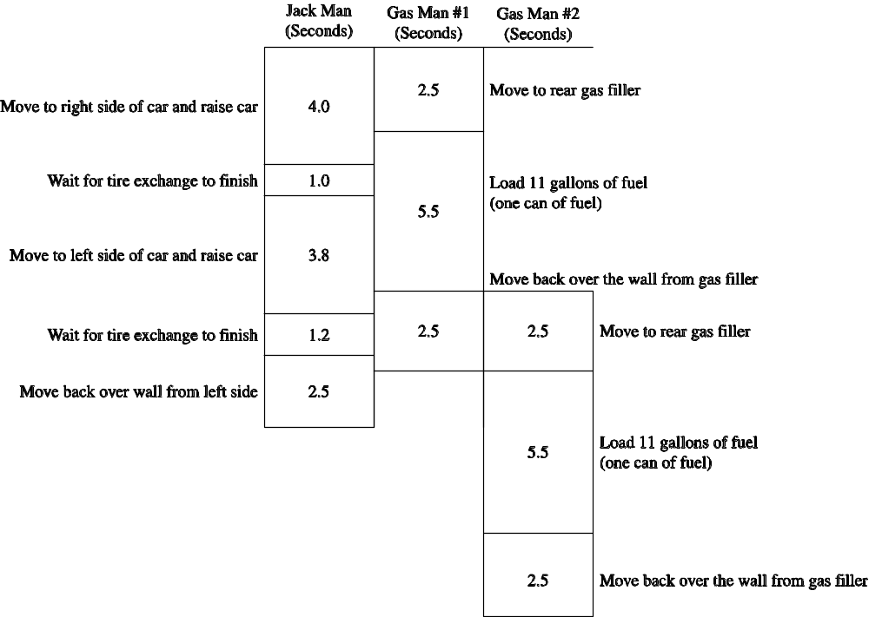
10.7

Times are based on those in Solved Problem 10.1. One could make the case that more (or less) overlap is possible between Gas Man #1 and Gas Man #2. Rules may also limit the number of “over the wall” crew allowed. This could change when the Gas Man #2 could start.

10.8
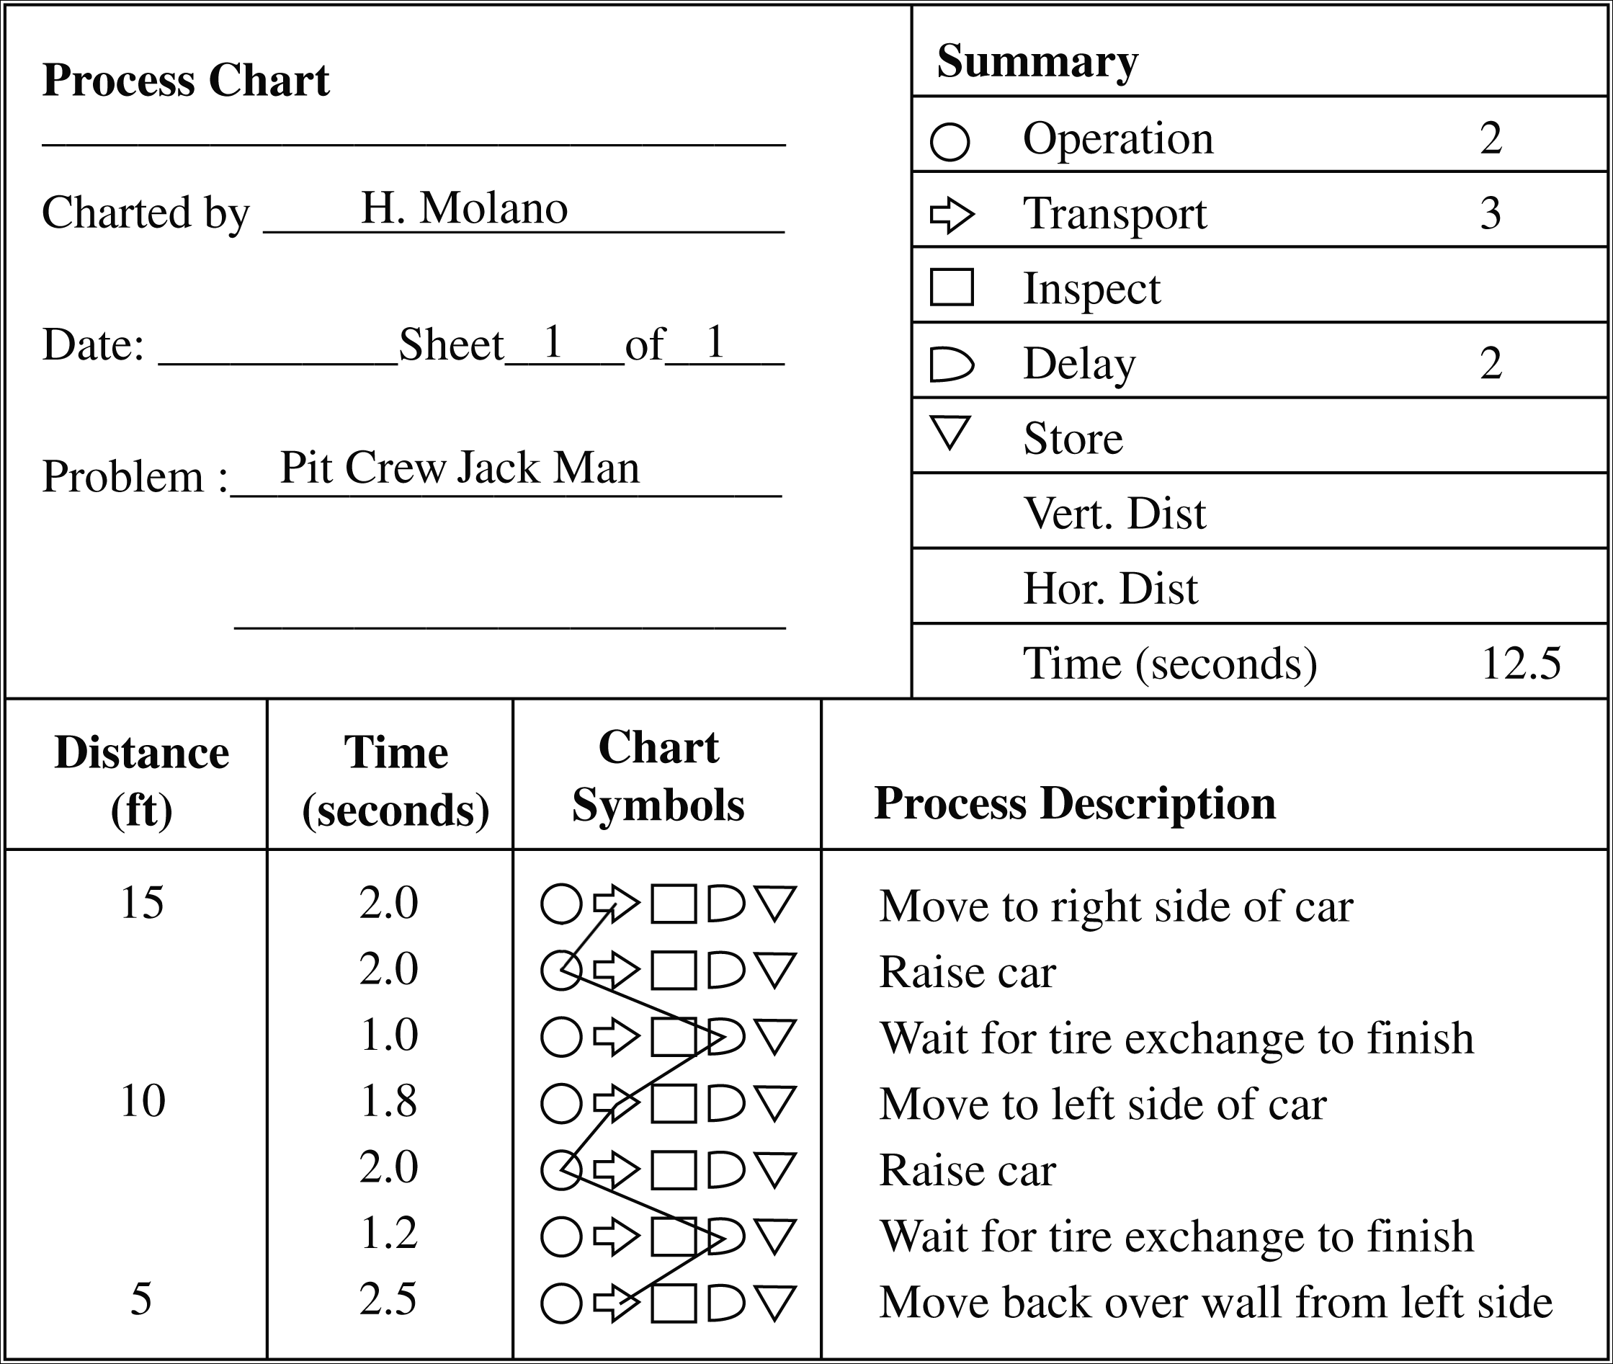

10.9 (a) One-Person Activity chart
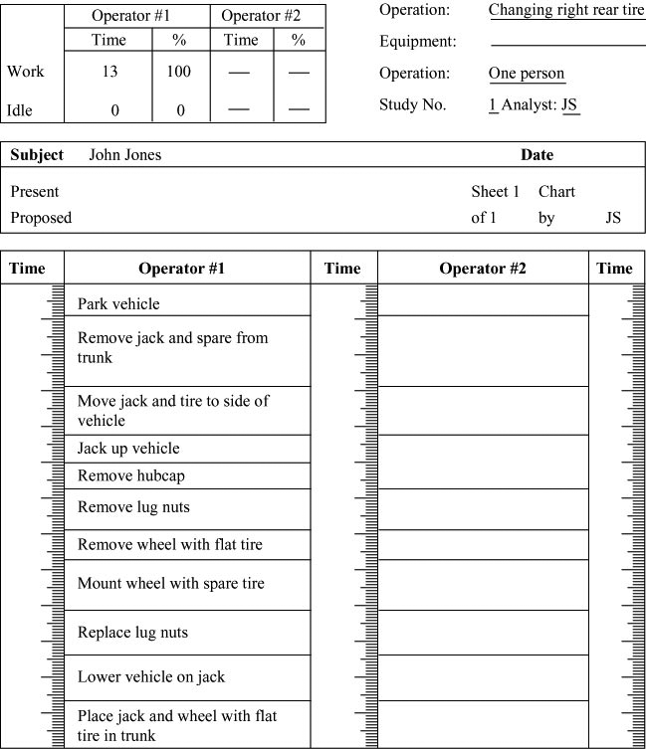

(b) Two-Person Activity chart
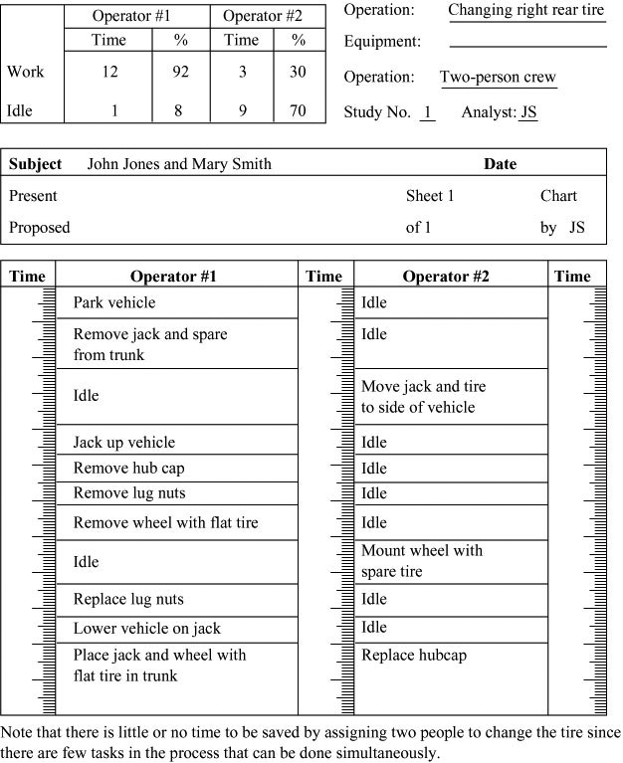
10.10
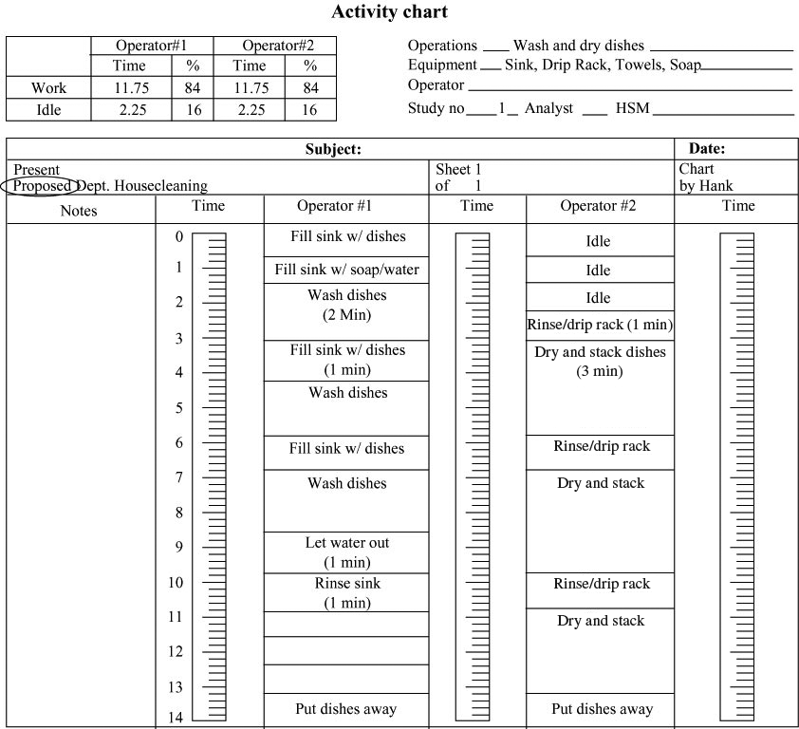
Washing takes about 2 minutes. Rinsing about 1 minute. Drying about 3 minutes. There appear to be no interferences except waiting for the dryer at the beginning and for the washer at the end. Both work approximately the same amount of the time so utilizations are equal. Individual responses may vary.
10.11 One way to do this is to divide the parts of the car
between the three people. For example, A can do the wheels and the top. B does the right side and hood, grill and bumper. C does the left side, trunk, and rear grill, lights, and bumper. Notes can be added under that column to give specific instructions and details.
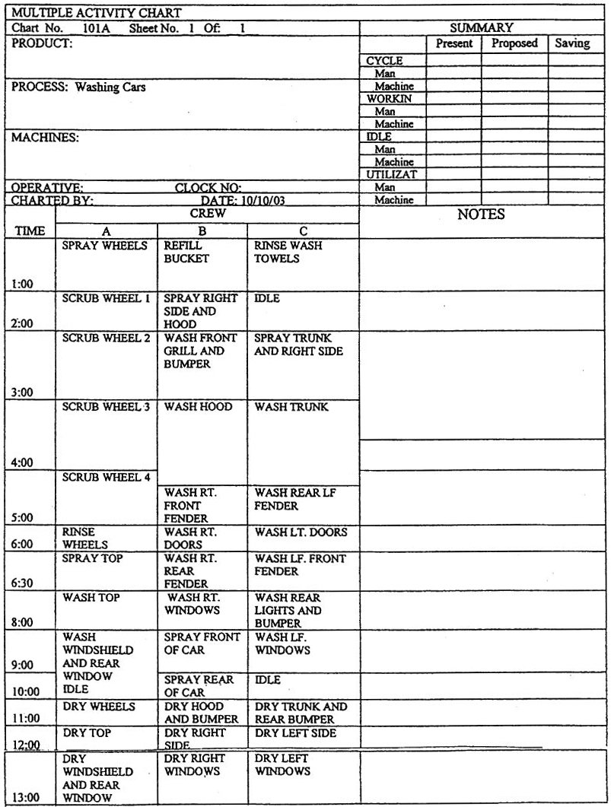
10.12
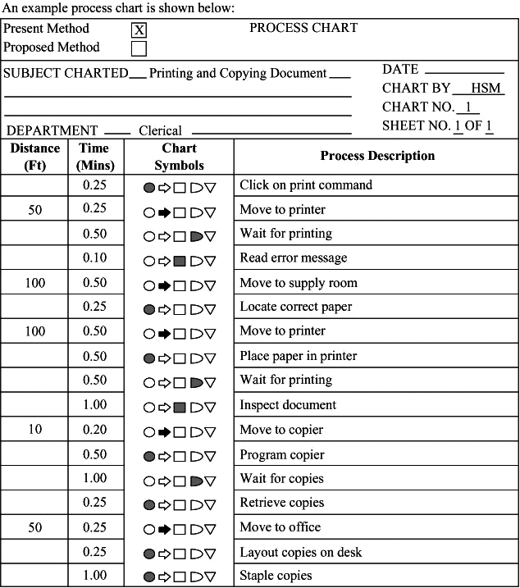

After analysis via a process chart above, encourage student to use some imagination. Additional short elements (open package, open printer tray, etc.) may be appropriate. Some ideas for improved efficiency include: Move printer adjacent to computer, move limited paper storage to a shelf adjacent to the printer; place stapler on the table adjacent to the copier; don’t wait for the printed copies, keep working until the printer is finished.
A more aggressive (and expensive) solution is to have a
sophisticated copier that takes the place of the printer (direct
from computer to copier) that does multiple sorted copies and staples them.
10.13 NT = Avg × PR = 8.5 × 1.10 = 9.35 seconds; worker is faster than normal
10.14 NT = Avg × PR = 8.5 × 0.90 = 7.65 seconds; worker is slower than normal
10.15 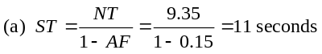
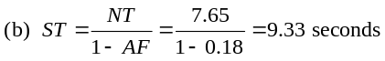
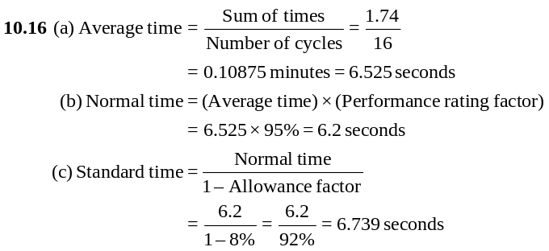10.17 NT = Average observed cycle time × PR = (50) × (1.10)
= 55 seconds
10.18 (a) Normal time = 12 minutes × 1.05 = 12.6 minutes
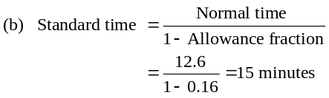
10.22
10.19 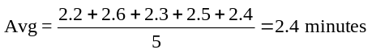
NT = 2.4 × 1.05 = 2.52
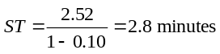
10.20 (a) Normal time = 12 seconds × 1.00 = 12.0 seconds
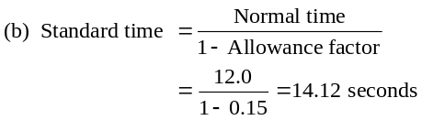
10.21 Normal time = 5.3 minutes × 1.05 = 5.565 minutes
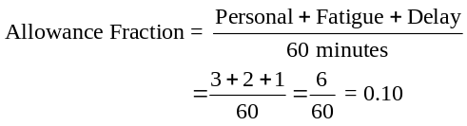
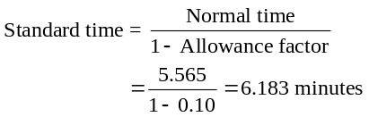

 |  |  | Observation (minutes par cycle)
Element | Rating | 1 |  | 2 | 3 | 4 | 5 | Average |  | Normal
Check mini-bar | 100% | 1.5 |  | 1.6 | 1.4 | 1.5 | 1.5 | 1.5 |  | 1.50
Make one bed | 90% | 2.3 |  | 2.5 | 2.1 | 2.2 | 2.4 | 2.3 |  | 2.07
Vacuum | 120% | 1.7 |  | 1.9 | 1.9 | 1.4 | 1.6 | 1.7 |  | 2.04
Clean bath | 100% | 3.5 |  | 3.6 | 3.6 | 3.6 | 3.2 | 3.5 |  | 3.50
 |  |  |  |  |  |  |  |  |  |  | 9.11

Normal time for process = 9.11

10.23
a Disregard—secretary stopped to answer the phone.
Job Element |  | Observed Time (minutes) |  |  |  |  | Perf. Rating
Typing letter | 2.5 | 3.5 | 2.8 | 2.1 | 2.6 | 3.3 | 85%
Typing envelope | 0.8 | 0.8 | 0.6 | 0.8 | 3.1a | 0.7 | 100%
Stuffing envelope | 0.4 | 0.5 | 1.9a | 0.3 | 0.6 | 0.5 | 95%
Sealing, sorting | 1.0 | 2.9b | 0.9 | 1.0 | 4.4b | 0.9 | 125%
b Disregard—interruption by supervisor.
Calculating average observed cycle time:
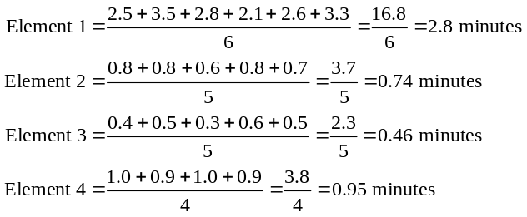
Calculating normal time for each task element:
Normal time = Observed cycle time × Peformance rating
Element 1 = 2.80 × 0.85 = 2.38 minutes
Element 2 = 0.74 × 1.00 = 0.74 minutes
Element 3 = 0.46 × 0.95 = 0.44 minutes
Element 4 = 0.95 × 1.25 = 1.19 minutes

10.24 (Contd)
(a) As shown below, normal time = 3.24 minutes.
10.23 (Contd)
Normal time for the process:
Normal time for process = Sum of normal times for elements
= 2.38 + 0.74 + 0.44 + 1.19
= 4.75 minutes
Standard time for process:
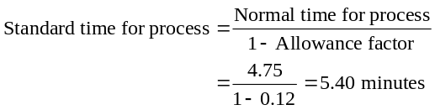
10.24 Allowance = 23%
The first thing to notice is that observation 4 of job
element 2 is personal time and should be ignored.
 |  |  | Observations (minutes)
Job  Element | Performance Rating | 1 |  | 2 | 3 | 4 | 5
1 | 97% | 1.5 |  | 1.8 | 2.0 | 1.7 | 1.5
2 | 105% | 0.6 |  | 0.4 | 0.7 | 3.7 | 0.5
3 | 86% | 0.5 |  | 0.4 | 0.6 | 0.4 | 0.4
4 | 90% | 0.6 |  | 0.8 | 0.7 | 0.6 | 0.7

 |  |  | Observations
Job  Element | Performance  Rating | 1 |  | 2 | 3 | 4 | 5 |  | Average  Actual Time | Normal  Time
1 | 97% | 1.5 |  | 1.8 | 2.0 | 1.7 | 1.5 |  | 1.70 | 1.65
2 | 105% | 0.6 |  | 0.4 | 0.7 |  | 0.5 |  | 0.55 | 0.58
3 | 86% | 0.5 |  | 0.4 | 0.6 | 0.4 | 0.4 |  | 0.46 | 0.40
4 | 90% | 0.6 |  | 0.8 | 0.7 | 0.6 | 0.7 |  | 0.68 | 0.61
 |  |  |  |  |  |  |  |  |  |  | 3.24

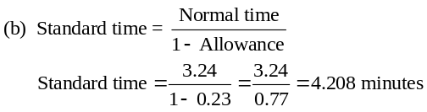
10.25 (a,b)
 |  |  | Observations (minutes)  (actual time) |  |  |  |  |  |  | Solutions
Task  Element | Performance  Rating | 1 |  | 2 | 3 | 4 | 5 |  | Actual  Time Average |  | Normal  Time
1 | 110% | 0.5 |  | 0.4 | 0.6 | 0.4 | 0.4 |  | 0.46 |  | 0.506
2 | 95% | 0.6 |  | 0.8 | 0.7 | 0.6 | 0.7 |  | 0.68 |  | 0.646
3 | 90% | 0.6 |  | 0.4 | 0.7 | 0.5 | 0.5 |  | 0.54 |  | 0.486
4 | 85% | 1.5 |  | 1.8 | 2.0 | 1.7 | 1.5 |  | 1.70 |  | 1.445
 |  |  |  |  |  |  |  |  | Total |  |  | 3.083
(a) Normal time = 3.083 minutes
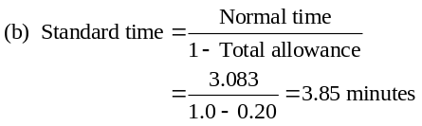

10.26 Initial sample: 3.5, 3.2, 4.1, 3.6, 3.9
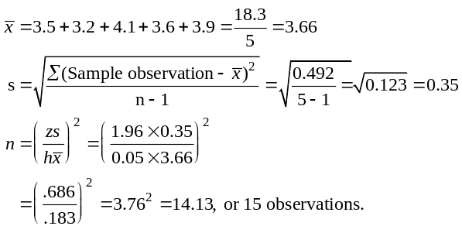
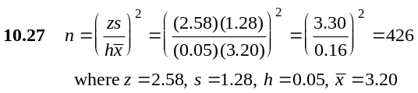
Sample size 45 is not adequate. They need 381 more observations.
10.28
Element | Observed Time (minutes) |  |  |  |  | Perf.  Rating
Prepare daily reports | 35 | 40 | 33 | 42 | 39 | 120%
Photocopy results | 12 | 10 | 36a | 15 | 13 | 110%
Label and package  reports | 3 | 3 | 5 | 5 | 4 | 90%
Distribute reports | 15 | 18 | 21 | 17 | 45b | 85%
a Photocopying machine broken (included in delay factor).
b Power outage (included in delay factor).
Calculating average observed cycle time:
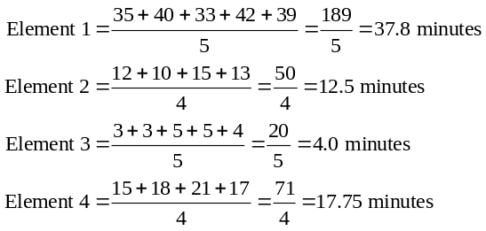
(a) Calculating normal time for each task element:
Normal time = Observed time × Performance rating
Element 1 = 37.80 × 1.20 = 45.36 minutes
Element 2 = 12.50 × 1.10 = 13.75 minutes
Element 3 = 4.00 × 0.90 = 3.6 minutes
Element 4 = 17.75 × 0.85 = 15.09 minutes
Normal time for the process:
Normal time for process = Sum of normal times for elements
= 45.36 + 13.75 + 3.6 + 15.09
= 77.8 minutes
(b) Standard time for the process:
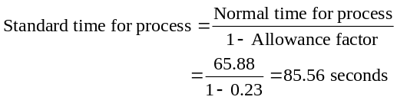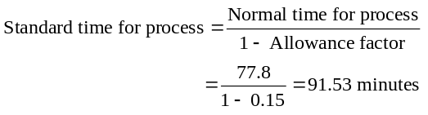
(c) Sample size:
From the equations relating to a normal distribution, we know
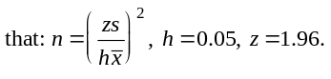
Job Element | Mean Cycle  Time | S² | S | Sample*
Prepare daily reports | 37.80 | 13.70 | 3.7 | 15
Photocopy results | 12.50 | 4.33 | 2.1 | 44
Label and package  reports | 4.00 | 1.00 | 1.0 | 96*
Distribute reports | 17.75 | 6.25 | 2.5 | 31
Sample size for the entire task must be at least 96 samples.
*All fractional sample sizes are rounded to the next highest integer value.
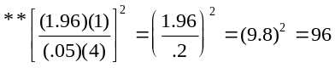
10.29 (a)
Job Element | Observed Time (seconds) |  |  |  |  | Perf.  Rating
Grasp and place  bag | 8 | 9 | 8 | 11 | 7 | 110%
Fill bag | 36 | 41 | 39 | 35 | 112a | 85%
Seal bag | 15 | 17 | 13 | 20 | 18 | 105%
Place bag on  conveyor | 8 | 6 | 9 | 30b | 35b | 90%
a Bag breaks open, include as part of delay in allowance factor.
b Conveyor jams, include as part of delay in allowance factor.
Note: If bags break open with any regularity, then these
observations would be included in the time for this element . . . it would be part of the element and task.
Calculating average observed time:
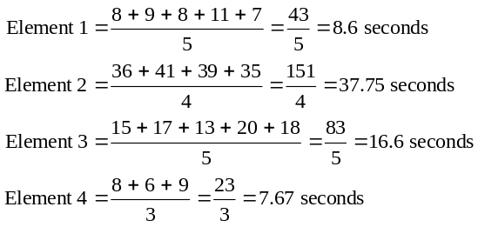
Calculating normal time for each task element:
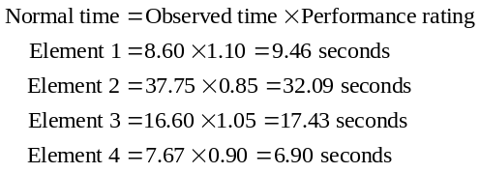
Normal time for the process:
Normal time for process = Sum of normal times for elements
= 9.46 + 32.09 + 17.43 + 6.90
= 65.88 seconds
Standard time for process:

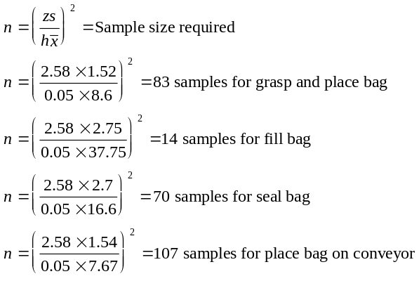
Calculating Sample Size
(b)  Job Element | Mean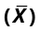 | Desired  Accuracy  (h) | Std. Dev.  Required  (Z) | Std. Dev. of  Sample  (S) | Samples  Required
Grasp and place bag | 8.60 | 0.05 | 2.58 | 1.52 | 83
Fill bag | 37.75 | 0.05 | 2.58 | 2.75 | 14
Seal bag | 16.60 | 0.05 | 2.58 | 2.70 | 70
Place bag on conveyor | 7.67 | 0.05 | 2.58 | 1.54 | 107

There fore, if all cycles must be studied together (the typical case), 107 cycles must be studied.
10.30 (a)
Job Element | Observed Time (minutes) |  |  |  |  |  |  | Performance  Rating
Select correct  muffler | 4 | 5 | 4 | 6 | 4 | 15* | 4 | 110%
Remove old  muffler | 6 | 8 | 7 | 6 | 7 | 6 | 7 | 90%
Weld/Install  new muffler | 15 | 14 | 14 | 12 | 15 | 16 | 13 | 105%
Check/inspect  work | 3 | 4 | 24* | 5 | 4 | 3 | 18* | 100%
Complete  paperwork | 5 | 6 | 8 | — | 7 | 6 | 7 | 130%
*Employee stopped to talk to boss—exclude (personal time).

Calculating average observed time:
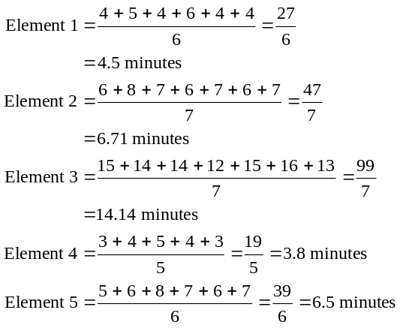
Calculating normal time for each task element:
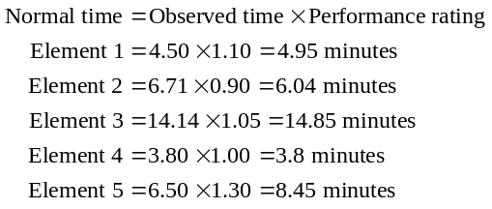
Normal time for the process:
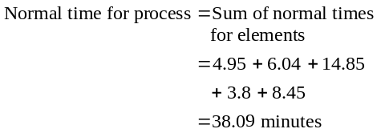
Standard time for process:
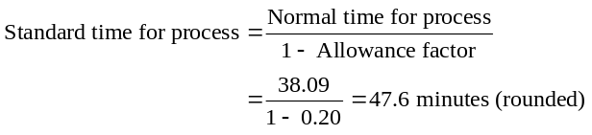

(b) Calculating sample size:
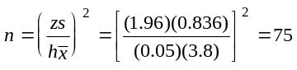
Job Element | Mean  Observed  Time | Desired  Accuracy  (h) | Std. Dev.  Required  (Z) | Std. Dev.  of Sample  (S) | Samples  Required
Select correct muffler | 4.50 | 0.05 | 1.96 | 0.836 | 53
Remove old muffler | 6.71 | 0.05 | 1.96 | 0.755 | 20
Weld/Install new muffler | 14.14 | 0.05 | 1.96 | 1.345 | 14
Check/inspect work | 3.80 | 0.05 | 1.96 | 0.836 | 75
Complete paperwork | 6.50 | 0.05 | 1.96 | 1.048 | 40
Element 4 required a sample of 75, thus the sample size for the study is 75.
10.31 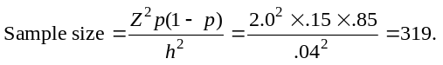
Therefore, minimum sample size is 319 samples.
10.32 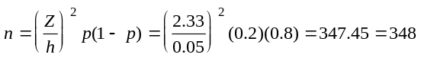 (rounded up)
10.33
(a) Standard time in minutes per chair = 480 minutes per day/
130 chairs
= 3.69 minutes
(b) Total allowances = 18% (6 + 6 + 6 = 18)
Normal time = Standard time × (1 − Allowance time)
Therefore:
3.69 × (1 − .18) = 3.69 × .82 = 3.026 minutes = Normal time
10.34 858 + 220 + 85 = 1,163
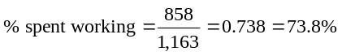
10.35 (a) 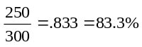

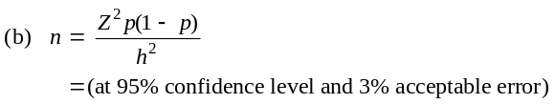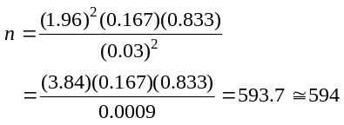
(c) The sample size was only about half the desired size.

10.36 |  | Motion | TMU’s
 | 1 | Reach 4 inches for the pencil | 6
 | 2 | Grasp pencil | 2
 | 3 | Move pencil 6 inches | 10
 | 4 | Position the pencil | 20
 | 5 | Insert the pencil into the sharpener | 4
 | 6 | Sharpen the pencil | 120
 | 7 | Disengage the pencil | 10
 | 8 | Move the pencil 6 inches | 10
 |  |  | 182
Given that 1 TMU = 0.0006 minutes: Time = 182 × 0.0006 = 0.1092 minutes (6.55 seconds)
10.37 Tell the supervisor that delay was over 8% and the sample
size was adequate (for a 95% confidence and 3% acceptable error):
Delay:
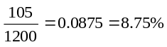
Sample size:
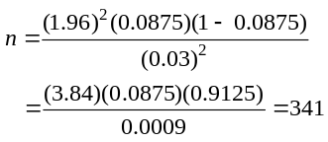
10.38
- Minutes available per day = 6 hours − 2 hours
= 4 × 60 min. = 240 min.
- Minutes of room cleaning required
200 room @ 30 min. each = 6,000 minutes
200 room @ 15 min. each = 3,000 minutes
Total of 9,000 minutes = 150 hours
- Each employee can clean 8 rooms (4 hr/.5 hr = 8)
Each employee can refresh 16 rooms
(4 hr/.25 hr = 16)
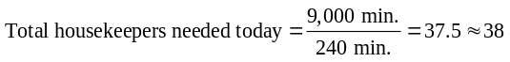
- 400 room @ .5 hr each = 200 hr
200/4 = 50 employees required to thoroughly clean all 400 rooms.

Additional Homework Problems
Here are solutions to additional homework problems that appear on our Web site www.pearsonglobaleditions.com/myomlab.
 |  | Observations (seconds/cycle) |  |  |  |  |  | Performance  Rating
Element | 1 |  | 2 | 3 | 4 | 5 | 6 | Performance  Rating
1 | 13.0 |  | 11.0 | 14.0 | 16.0 | 51.0* | 15.0 | 100%
2 | 3.0* |  | 21.0 | 25.0 | 73.0* | 26.0 | 23.0 | 110%
3 | 3.0 |  | 3.3 | 3.1 | 2.9 | 3.4 | 2.8 | 100%
10.39
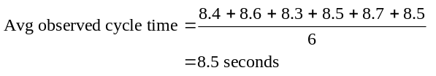
10.40 (a) Normal time = 10 minutes × 1.10 = 11 minutes
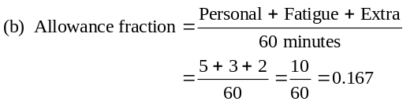
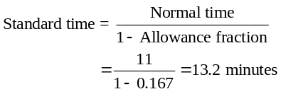
10.41
*Disregard—possible error
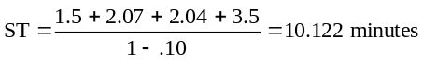

10.43 Measurement data:
10.42 Measurement data:
*Disregard—may be unusual observations—check to see if times are legitimate.
Calculating average observed cycle time:
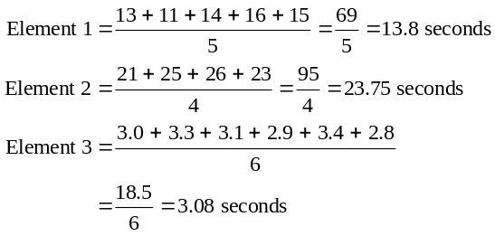
Calculating normal time for each task element:
Observations
(minutes per cycle)
Element |  | Rating | 1 | 2 | 3 | 4 | 5 | Average  Time | Normal  Time
1 | 100% |  | 1.5 | 1.6 | 1.4 | 0.1* | 1.5 | 1.5 | 1.50
2 | 90% |  | 2.3 | 2.5 | 2.1 | 2.2 | 2.4 | 2.3 | 2.07
3 | 120% |  | 1.7 | 1.9 | 1.9 | 1.4 | 1.6 | 1.7 | 2.04
4 | 100% |  | 3.5 | 3.6 | 3.6 | 3.6 | 3.2 | 3.5 | 3.50
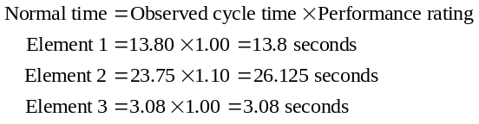
Normal time for the process:
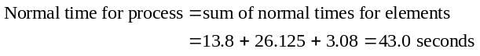
Standard time for process:
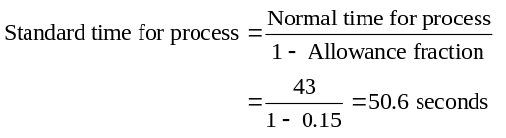

Observations (seconds/cycle)
Element | Performance Rating | 1 | 2 | 3 | 4 | 5 | 6 | 7
1 | 90% | 1.80 | 1.70 | 1.66 | 1.91 | 1.85 | 1.77 | 1.60
2 | 100% | 6.90 | 7.30 | 6.80 | 7.10 | 15.30* | 7.00 | 6.40
3 | 115% | 3.00 | 9.00* | 9.50* | 3.80 | 2.90 | 3.10 | 3.20
4 | 90% | 10.10 | 11.10 | 12.30 | 9.90 | 12.00 | 11.90 | 12.00
*Disregard—unusual observation (reevaluate prior to including)

Calculating average observed cycle time:
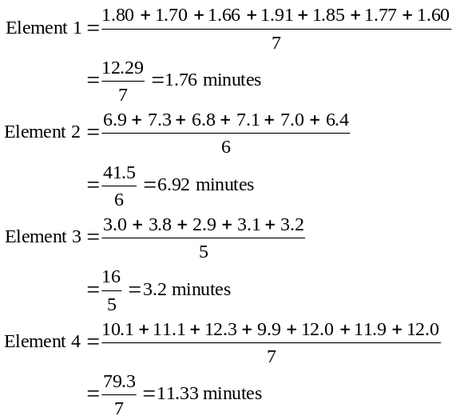
Calculating normal time for each task element:
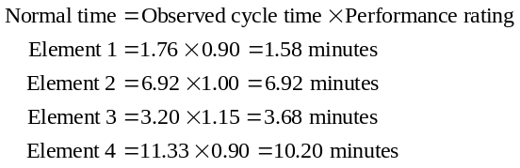
Normal time for the process:
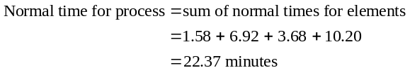
Standard time for process:
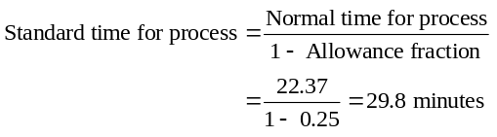
10.44
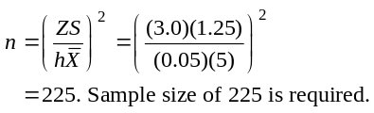
10.45
= Average task time = 1.5 minutes
S = Standard deviation of the cycle = 0.0707
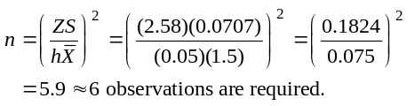
10.46
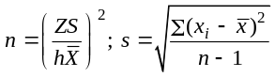
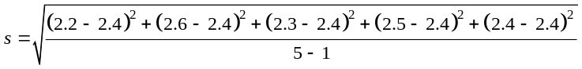
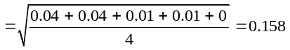
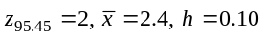
10% accuracy:
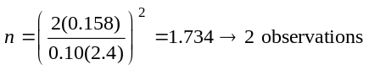
5% accuracy:
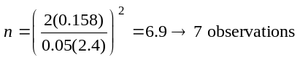
Case Study
JACKSON MANUFACTURING CO.
1. Actual observed cycle times
x |  |  | 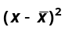
2.05 | 1.90 | 0.1488 | 0.0221
1.92 | 1.90 | 0.0188 | 0.0004
2.01 | 1.90 | 0.1088 | 0.0118
1.89 | 1.90 | −0.0112 | 0.0001
1.77 | 1.90 | −0.1312 | 0.0172
1.80 | 1.90 | −0.1012 | 0.0102
1.86 | 1.90 | −0.0412 | 0.0017
1.83 | 1.90 | −0.0712 | 0.0051
1.93 | 1.90 | 0.0288 | 0.0008
1.96 | 1.90 | 0.0588 | 0.0035
1.95 | 1.90 | 0.0488 | 0.0024
2.05 | 1.90 | 0.1488 | 0.0221
1.79 | 1.90 | −0.1112 | 0.0124
1.82 | 1.90 | −0.0812 | 0.0066
1.85 | 1.90 | −0.0512 | 0.0026
1.85 | 1.90 | −0.0512 | 0.0026
1.99 | 1.90 | 0.0888 | 0.0079
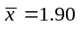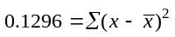
h = 0.05, n = 17, z = 3
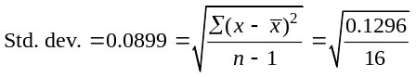
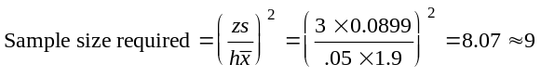
This can be rounded up to 9 for statistical accuracy.
2. A sample size of 17 is more than adequate, given the low variation in cycle times; indeed, a sample size of 8 or 9 would be adequate.
3. Available time = 7.5 × 60 = 450 minutes
Observed cycle time = 1.90; normal time = 1.90 × 1.15 = 2.185
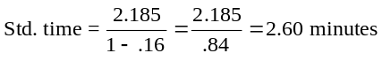
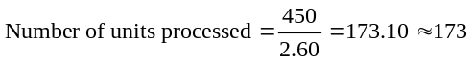
4. $100 = ($12.50 × 8.0) = total cost per day
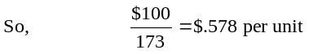
Video Case Study
HARD ROCK’S HUMAN RESOURCE STRATEGY
There is an 8-minute video, available from Pearson Education, filmed specifically for this text that can be shown at this time.
1. Hard Rock has lower employee turnover than the industry
due to its
- thorough screening at hiring
- tolerant, even accepting culture of diversity
- great benefit package
- effective indoctrination and training, empowerment
- focus on team work and even outside volunteer work.
2. The human resource department supports the overall theme restaurant strategy (the experience economy concept) by aggressive
screening, including an evaluation of how the employee will contribute to the Hard Rock experience. The human resource department at Hard Rock recognizes that they are responsible for a critical
element in Hard Rock’s strategy. So they must recruit and retain the
human capital that is necessary to fulfill that mission and strategy.
3. An automobile assembly line probably allows less opportunity for creativity and individual expression than a waiter or waitress at Hard Rock, although both organizations can probably put motivated well-trained personnel to good use.
4. The job design literature is rich with many improvements that can be made in the traditional assembly line. The Hackman and Oldham core job characteristics can, with a little imagination, be applied to the assembly line. Job rotation can aid Skill Variety; helping employees see the fruits of their labor in the finished product will help with Job Identity and Job Significance; providing opportunity for self-direction by adding planning and control tasks to the job can contribute to Autonomy; and Supervisory Feedback is easy for the tuned-in supervisor. All these are further augmented by job enlargement, job enrichment, Maslow’s self-actualization, and Hertzberg’s motivators, such as responsibility, the work itself, recognition, advancement, and achievement. And, of course, the hygiene factors of security, status, working conditions, pay, interpersonal relations, supervision, and company policy and administration can all play a positive role in the quality of life on the job/assembly line. Note: Maslow’s hierarchy and Hertzberg’s dual factors are not discussed in the chapter.

Additional Case Studies
CHICAGO SOUTHERN HOSPITAL
1
1. Sampling Plan:
- Do studies on all shifts (probably four shifts; three each day plus the weekend shift) to get data on workload differences by shift. Then cross-check with other studies by function (intensive care, maternity, postoperation, etc.). If identifiable differences are present, then judgments will need to be made about additional studies.
- It may well be that major differences exist, suggesting that more extensive studies be made.
- Generate a random sample of which nurse to sample when using a true random device, such as the random number table provided in the text in Appendix III.
- Perform an adequate number of samples (per question 2).
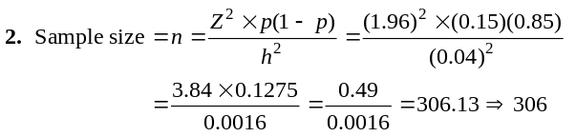
Note: The sample size will change if the 15% vs. 85% is not close to accurate. This difference may suggest that a larger sample be taken.
3. By structuring the study across different nurses, different shifts, and different hospital processes (areas/functions), there should be an adequately diverse cross section. Some postsample check to ensure a mix of nurses, shifts, and functions should be made.

KARSTADT vs JCPENNEY
2

The case examines the differences in work ethic between a
German department store employee and an American department store employee.
Key Points
- Andreas Drauschke and Angie Clark hold positions at similar levels in department stores, and receive similar pay. However, Drauschke, who works in Germany, works far fewer hours than Clark, who works in the U.S.
- In fact, Drauschke works just 37 hours a week, and receives six weeks vacation each year, while Clark works at least 44 hours
a week, and takes off only a week at a time. Clark notes that Germans see leisure time as being more important than work time.
- The difference between the German work style and the American
work style extends in to other areas. For example, turnover at the German store is all but nonexistent, while at the American store it is 40 percent a year. In addition, German employees
receive extensive training, while workers at the American store receive minimal instruction.
- Many employees at the American store also have a second job, however Drauschke values his free time, and works no longer than absolutely necessary. His view point is shared by other Germans who fiercely protested the recent mandate that depart-ment stores would stay open one evening each week. Germany also prohibits working second jobs during vacation time.
* These cases can be found on our Companion Web site,
www.pearsonglobaleditions.com/heizer.

1. How does the work culture in the United States differ from that in Germany?
Human resource management (HRM) refers to the activities directed at attracting, developing, and maintaining an effective workforce to achieve an organization’s objectives. Students will probably conclude that at least in the retailing
industry, American HR managers spend less time both in
recruiting and selecting managers, and preparing them for their jobs than their German counterparts. As a result, turnover is very high in the U.S. as compared to Germany. While the case does not provide information regarding how employees in either country are evaluated, the total compensation package received by Germans seems to be preferable to that which American workers receive.
2. What do you see as the basic advantages and disadvantages of each system?
Most students will probably suggest that the extensive effort that appears to go into selecting and training German workers is a clear advantage of the German system. Students taking this perspective are likely to support their contention by pointing to the high turnover rate in the U.S. as compared to Germany. Many students may see the restriction faced by German workers regarding second jobs as being an intrusion in an individual’s private life, and therefore see it as a disadvantage. Finally, most students will probably agree that the compensation package received by German workers is far more likely to improve employee morale than the package
received by American workers.
3. If you were the top operations executive for an international department store chain with stores in both Germany and the United States, what basic issues would you need to address regarding corporate human resource policies?
A primary issue that would have to be addressed is the difference in compensation packages between the U.S. and
Germany. German workers have shorter work weeks and far more vacation time than their American counterparts, yet receive similar pay. A second issue that would have to be
addressed is the difference in worker training and development. German department stores may spend two or three years preparing employees, while American stores might spend just two or three days. Furthermore, recruiting and selection issues would have to be addressed, not only because German employees frequently complete an apprentice program prior to becoming full-time employees, and thus require very careful selection, but also because turnover is much higher in the U.S. than in Germany.
4. Are retailing employee issues different than other industries?
Most students will probably suggest that the issues outlined in question 3 above are probably important in all industries. One area that might be different is the issue of turnover. While turnover is very high in U.S. retailing, it is likely to be less of a problem in industries where workers receive extensive training and/or belong to unions.
5. Under which system would you prefer to work?
Most students will probably suggest that the German work system is preferable than the American work system. Students taking this perspective will probably point out that American workers frequently appear to be stressed out on the job and do not have enough time with family. Other students, however, might object to some of the constraints of the German system, such as the prohibition of second jobs during vacation time. Students taking this perspective are likely to suggest that there should be no limits to working as hard as possible in order to get ahead.
Additional Case Application
Case question 3 asks students to identify issues that would be faced by an American operations manager who worked for an in-ternational department store chain with branches in both the U.S. and Germany. Students can carry this exercise one step further by holding a round table discussion reading compensation packages. Each student can be assigned to take on the role of either the American executive, a German worker, or an American worker.
Source: R.W. Griffin and M.W. Pustay, International Business 2nd ed. (Reading, MA, Addison-Wesley), 1999. Solution appears on page
347–349 of Instructor’s Manual by V. Horton and S.K. Sokoya.

THE FLEET THAT WANDERS
3
Can you imagine an analytical approach to documenting the problems reported by drivers?
We often use this case to explain that not all problems of this nature are behavioral. Indeed, this is a true case designed to show students that, based on what is known about human factors, the sit-
uation can be studied analytically. The design methodology for documenting Mr. Southard’s case was to put monitors on the truck
drivers to provide a record of their cardiovascular activity. Most of
the drivers were doing day drives, that is, going and returning on the same day, thus the design called for monitoring a number of trips by each driver over the same routes using both the new and old trucks. In this way, comparisons could be made between the work required to drive each truck as shown on the records from each driver. Additionally, the steering wheel on each truck was fit-
ted with sensors to record the amount of motion required to control each kind of truck. The hypothesis was that the truck that
required more work would also require greater steering wheel movement. The measure of steering wheel movement was used as evidence to validate the work implied by the record of cardiovascular activity.
There were, of course, some difficulties with this design. It was expensive to outfit the trucks and drivers with the monitoring devices. The cooperation of the drivers was needed because the use of the monitors constituted an invasion of privacy. In addition, on longer trips, the cardiovascular sensors needed to be removed before, and reattached after, every break or delivery stop.
Note: This can make for an excellent classroom exercise and discussion.

